

IT3060 - Human Computer Interaction

Assignment 1

Craigslist.org

2023-WE-S1-13

DreamWeave

**Member Details**

|  |  |  |
| --- | --- | --- |
| **Reg. No** | **Name** | **Work Distribution** |
| IT21181474 | Hettiarachchi H.K.Y. K | Identify the usability issues.  User Groups Identify  Make Gantt Chart  Identify and add ratings of the usability problems.  Contribute to make the report |
| IT21360046 | Jayasekara B.B.R.Y | Identify the usability issues  User groups identified.  Edit report.  Identify usability issues referring the videos. |
| IT21358616 | Munasingha M.H.C |  |
| IT21356636 | Perera P.K.L | Identify the usability issues.  Create a persona.  User group Identify.  Edit a video. |
| IT21345746 | Siriwardana A.P.G.D.P | Identify the usability issues.  Contribute to make the report.  Contribute to the interview.  Issues using contextual inquiry. |

# Project Description

Our team chose the website called “Craigslist” the one of most well-known websites for online marketplace. The primary purpose of this website is to connect users within specific geographical areas, enabling them to post listings for items, services, housing, jobs and more. Users can explore listings, communicate with sellers through mail, and negotiate transactions directly. Its simplistic, Text-heavy interface and lack of modern designs (e.g. images etc.) can be occur as usability challenges for users.

# Alternatives Considered

We considered several alternative considerations. Our team members chose [Blinkee.com](https://blinkee.com/), [Chestertourist.com](http://www.chestertourist.com/) and [nh.craigslist.org](https://nh.craigslist.org/) websites. First, we chose blinkee.com but everyone is going to do that site because every requirement that has given by our module is fulfilled in that website. After considering the given instructions in our HCI module we came up with the **Craigslist** website.

# User groups identified.

User groups

Apartment Seekers

Job Hunters

Novice Sellers

Novice Sellers: Individuals who are new to the website trying to sell items.

Apartment Seekers: Users who are looking for rental housing.

Job Hunters: People searching for Job opportunities.

# Personas

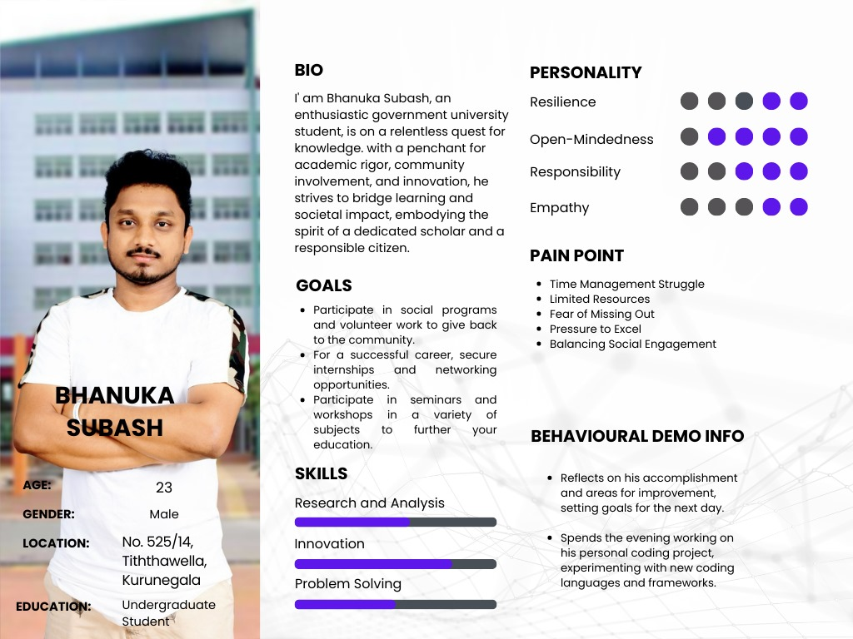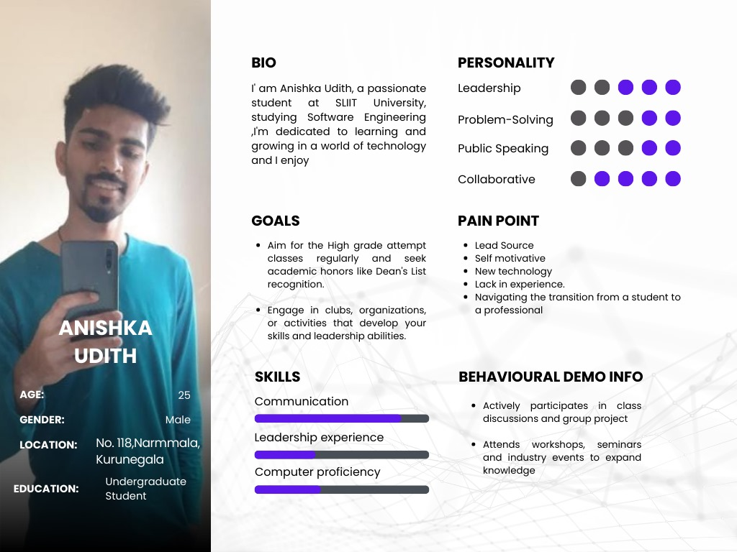

# Usability Issues

* Confusing text and links.
* Navigations are hard to understand.
* Not a filtering system for the category.
* No header
* Layout problems
* Not organized interfaces in an effect way.
* No back buttons or other buttons.
* Any user can change or delete the data on the website.
* No usage of identity of the website (No logo added, Confusing pages like feedback)
* No affective color usage.
* Difficult to understand instructions and some content included on the website. (Page contents are complex)
* Hides information.
* Hard to find some information quickly because of no highlights.
* The background color is not eye catching and no eye-catching colors (Not attractive)
* No special points are not Highlighted.
* Fonts are too small.
* Have a busy environment.

# Scripts for contextual inquiry

## Craigslist.org: User Category – **Undergraduate Student**

|  |  |  |
| --- | --- | --- |
| Background description of the user | Questions to be asked from the user | Tasks to be given to the user |
| Aniska Udith is a passionate student at SLIIT University. He is a person who is always willing to learn new technologies and get high grade classes. He is into a lot of different activities to show and improve his skills and qualifications. | What is the main problem when using the website?  What kind of improvements  Do you wish to have here? | “Go to the make a post section.”  “Move to the housing section and tell me about the design of the page.”  “Go to the community page.” |

## Craigslist.org: User Category – **Hotel Manager**

|  |  |  |
| --- | --- | --- |
| Background description of the user | Questions to be asked from the user | Tasks to be given to the user |
| Sandalu Samarakoon is a hotel manager. He is a person who is committed to guest satisfaction. He is passionate to improve the productivity of his job role. | What are the think about facilities on this website?  Have you use this in your mobile phone” tell me it is mobile responsiveness ? | “Go to the Jobs category and find the errors on this page.”  “Go to services page and tell me about error did you faced.” |

## Craigslist.org: User Category – **Undergraduate Student**

|  |  |  |
| --- | --- | --- |
| Background description of the user | Questions to be asked from the user | Tasks to be given to the user |
| Bhanuka Subash is an enthusiastic government university student. He is a person who is always seeking opportunity to succeed in his career and secure his internship by enroll in a lot of different activities. |  |  |

# Sharable link of the upload video

[**http://bit.ly/userInterview**](http://bit.ly/userInterview)

# Usability issues identified using contextual inquiry.

# Ratings

# Time Schedule (Gantt Chart)

|  |  |  |  |  |  |
| --- | --- | --- | --- | --- | --- |
| Task | Week 1 | Week 2 | Week 3 | Week 4 | Week 5 |
| Group registration |  |  |  |  |  |
| Website Selection |  |  |  |  |  |
| Workload Distribution |  |  |  |  |  |
| Identify Usability Issues |  |  |  |  |  |
| Stakeholder Identification |  |  |  |  |  |
| Creating Personas |  |  |  |  |  |
| Creating Contextual Inquiry |  |  |  |  |  |
| Recording Videos |  |  |  |  |  |
| Make the Document |  |  |  |  |  |
| Submit Assignment 1 |  |  |  |  |  |

# References

1. Expert tips for writing a project description

By : Kate Eby on May 25,2021

Received date: August 03,2021

Link: <https://www.smartsheet.com/content/project-description>

2 . 6 Steps to identify Usability Problems

By:Jeff Sauro,PhD on September 17,2013

Received date: August 05,2021

Link: <https://measuringu.com/six-steps-usability-problems/>

# Appendix

Hettiarachchi H.K.Y.K.

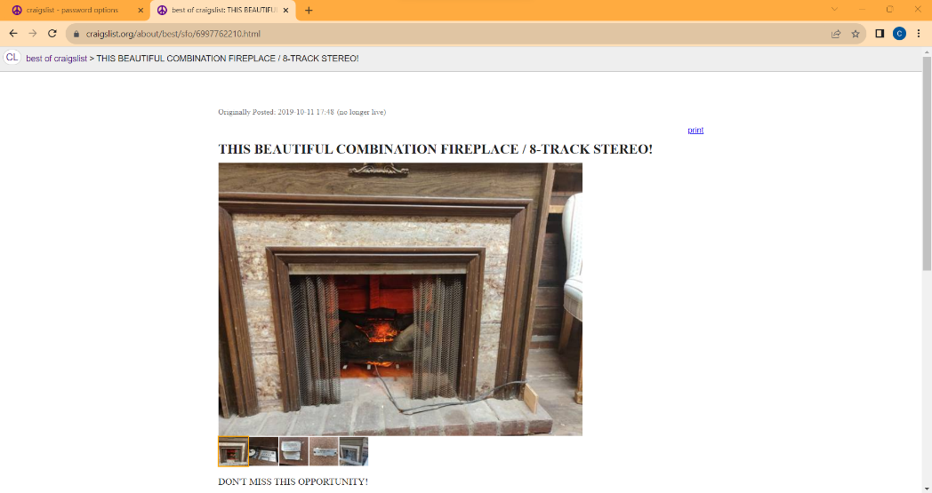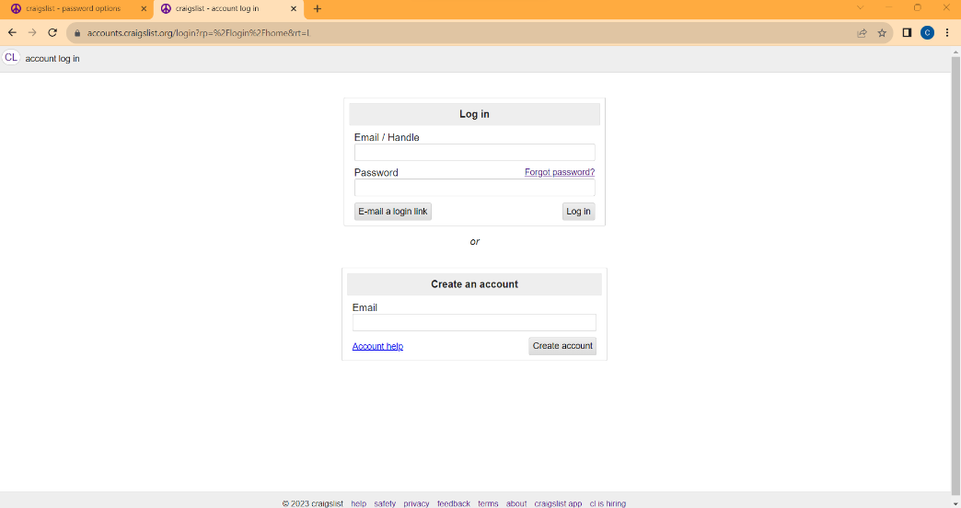IT21181474

Figure 12‑1:• about-> best of craigslist-> THIS BEAUTIFUL COMBINATION FIREPLACE / 8-TRACK

Figure 12‑2:• account log in

* about-> best of craigslist-> THIS BEAUTIFUL COMBINATION FIREPLACE / 8-TRACK STEREO!
* account log in
* password options

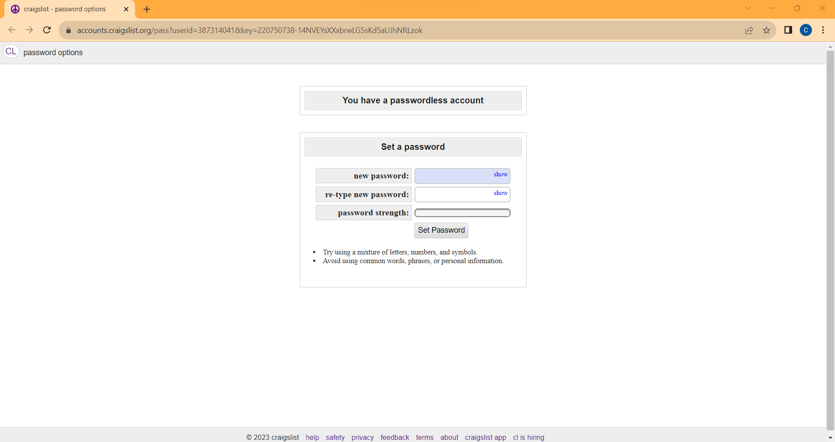

Figure 12‑3:• password options

Jayasekara. B.B.R.Y

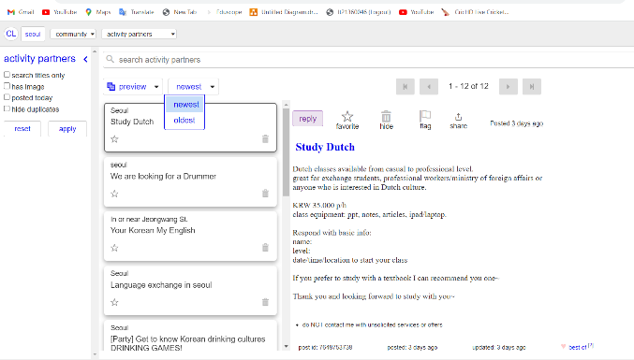IT21360046  
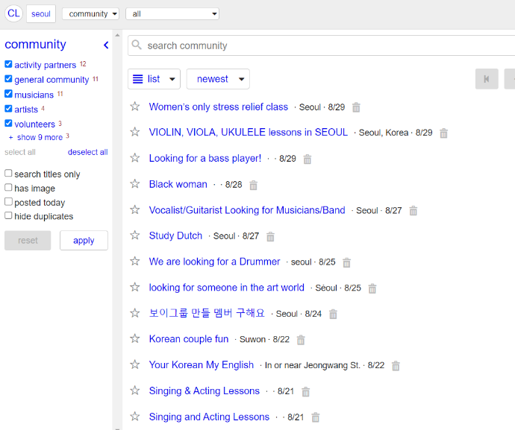

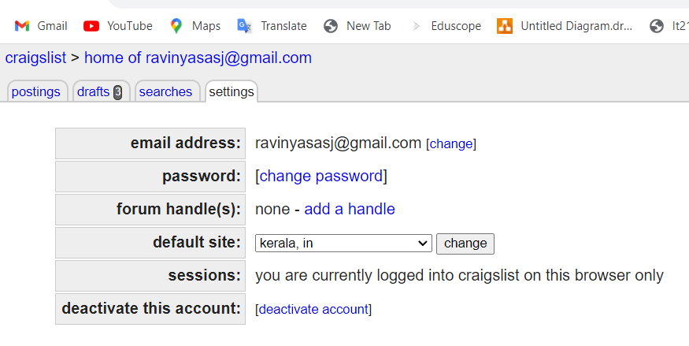

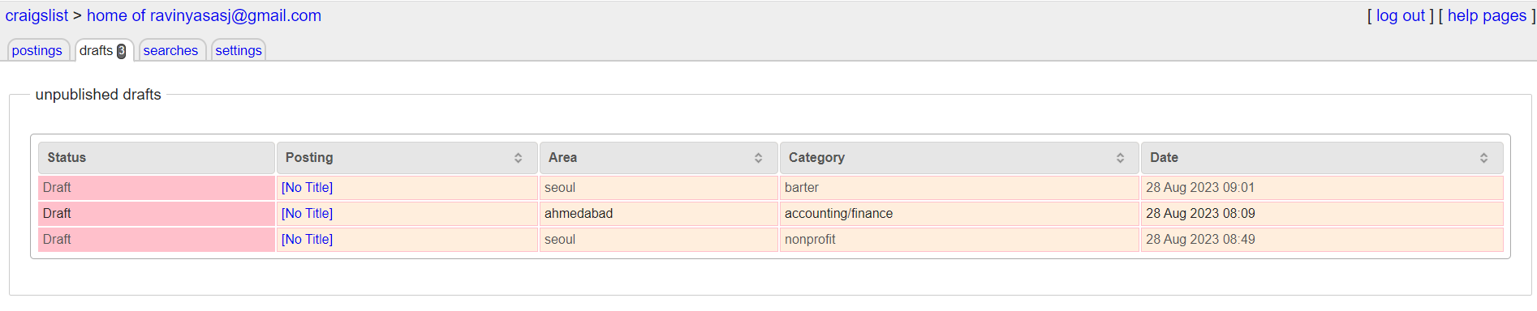

Siriwardana A.P.G.D.P

IT21345746

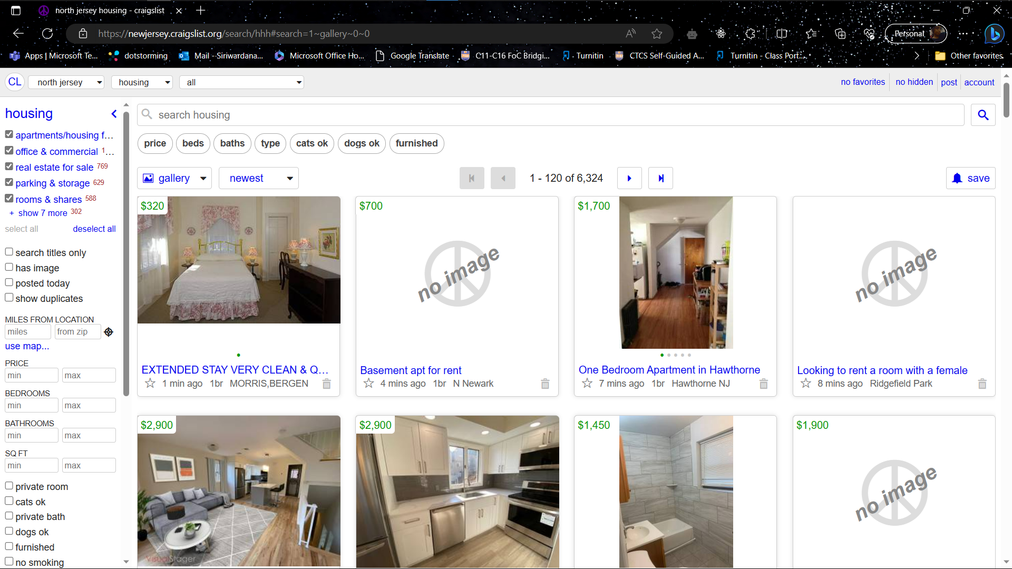Housing page

Home page

Event page

Munasingha M.H.C

IT21358616



